**WHO input to the WMO state of the climate report**

**Generic Text on Climate and Health linkages**

Multiple and complex connections between climate and health exist across timescales, and are being observed by health professionals worldwide. The health chapter of the most recent report of the IPCC (2) (ref) – divides these into three main groups: 1) The direct impacts on human health, such as those which arise from damages and illness from exposure to increased frequency and severity of extreme weather events; 2) Impacts mediated through other environmental systems. These include rising air pollution, and changing patterns of vector-, food- and water-borne diseases; 3) Socially mediated effects, which occur via climate change’s interaction with social and human systems, such as health effects resulting from undernutrition, occupational heat stress and mental illness, as well as potential increases in population displacement and risks of violent conflict, and slowing of economic growth and poverty reduction. Some impacts of climate may be positive, such as decreased local disease transmission or increased agriculture yields, but the overwhelming majority of impacts are negative, occur in already vulnerable populations and represent a collective risk that is deeply concerning to the global health community. Table X summarizes some of the most important expected impacts of climate change by the middle of the current century[1].



Table X Summary of the main expected health impacts of climate variability and climate change globally by the middle of the current century Source: WHO

**Part 2 - 2017 Observations**

In 2017, the WHO observed numerous health risks and impacts consistent with the known sensitivity and trends of how climate change influences health, including: increasing exposures to heat stress, the accelerated transmission of vector-borne diseases; disease outbreaks related to flooding; and extended and delayed onset of El Nino related impacts; wildfire related injuries and respiratory problems.

**Heatwaves**

Recent research shows that the overall risk of heat-related illness or death has climbed steadily since 1980, with around 30% of the world’s population now living in climatic conditions that deliver deadly temperatures at least 20 days a year.[2] Between 2000 and 2016, the number of vulnerable people exposed to heatwave events has increased by approximately 125 million, with a record 175 million more people exposed to heatwaves in 2015[3].” Total heatwave deaths in 2017 are estimated at… with much greater impact on wellbeing and productivity.

**ENSO**

The 2015/16 El Niño episode caused drought, flooding and severe storms, prompting 23 countries to seek humanitarian assistance for over 60 million people. While the El Niño episode ended in May 2016, East and Southern Africa the health impacts of this event have delayed onset and long duration, with related impacts continuing to be observed throughout 2017 in vulnerable populations in parts of Eastern and Southern Africa, Asia and the Pacific, the Dry Corridor in Central America, and Haiti in the Caribbean. This event will also cause long term consequences for public health, interlinked with conditions of nutrition, livelihoods, water and sanitation.

**Vector-borne diseases: Zika in the Americas**

Vector-borne diseases are highly climate sensitive and favourable climate conditions can trigger and amplify disease transmission. This is thought to be the case with the emergence of the Zika virus (ZIKV) carried by the *aedes* mosquito in Latin America and the Caribbean in 2014-2016 which occurred during a period of severe drought and unusually high temperatures, associated with the 2015-2016 El Niño event.[4] The initial Brazilian outbreak appears to have been aided by a drought driven by El Niño, and by higher temperatures. With studies identifying a “striking overlap” between areas in Brazil that were afflicted by extreme weather conditions, and areas where Zika virus cases emerged one month later.[5] Currently in 2017, local transmission and the associated and resulting foetal malformations and neurological disorders continue to be monitored and recorded in the region, and worldwide.

**Water-borne diseases: Cholera in Africa**

Cholera remains a significant public health problem in many parts of the world. In 2016, 38 countries reported a total of 132 121 cases including 2420 deaths. In cholera-endemic countries, an estimated 1.3 billion people are at risk, while in Africa alone, about 40 million people live in cholera hotspots[6]. These cholera “hotspots” have been identified across most endemic countries facing recurrent and predictable cholera outbreaks, often coinciding with the rainy season. The WHO has recognized that large cholera outbreaks in East and Central, and later Southern Africa were likely aided by El Nino driven weather conditions that accelerated transmission across the region starting in mid-2015, with control efforts still underway in several countries in 2017.[7] A 2017 study, has observed that the annual geographic distribution of cholera in Africa from 2000 to 2014 changes dramatically in relation to ENSO states, with the burden shifting to continental East Africa where increased rainfall is experienced and almost 50,000 additional cases occur during El Niño years - and away from Madagascar and portions of southern, Central, and West Africa[8]. However, the study also observed cholera incidence was also higher in some areas with decreased rainfall, suggesting a complex relationship between rainfall and cholera incidence exists, and is likely mediated by local water and sanitation conditions and health care access.

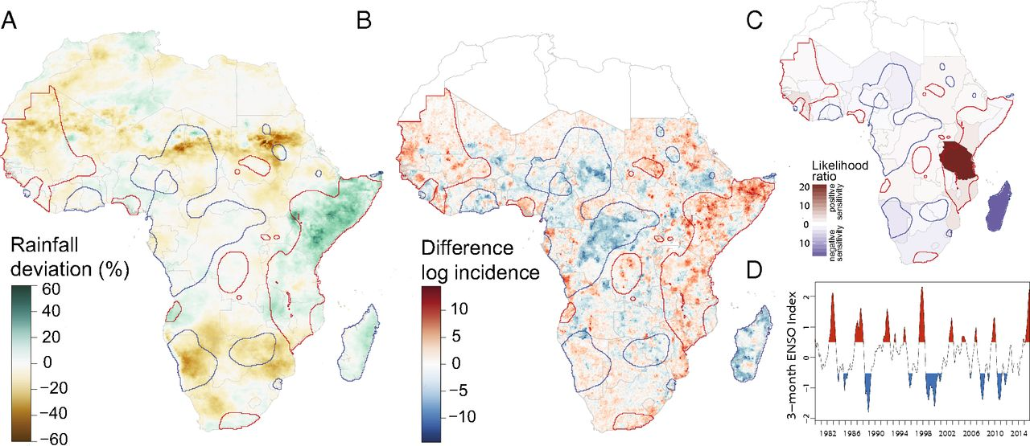 <http://www.pnas.org/content/114/17/4436/F1.expansion.html>

**Outbreaks, Injury, Death, and mental impacts of and flooding**

The worst floods in a century have affected Bangladesh, India, Pakistan, and Nepal affecting more than 41 million people. The risk of communicable diseases, particularly fecal oral diseases, also increases in flooded areas[9]. In Bangladesh alone, more than 13,000 cases of waterborne diseases and respiratory infections have been reported during 3 weeks in August.[10] 1200 deaths reported

In Nepal following heavy rainfall in August 2017 public health facilities reportedly affected include: 39 public hospitals, 109 primary health care centres and 1,554 health posts. 10 fully damaged and 64 partially damaged, while others reported inundation and disruption to health services several days.[11]

DCL please ADD – Standard WHO Disclaimer

1. WHO. Climate and Health Profile Overview. 2015. Geneva
2. Mora 2017. Nature Climate Change 7, 501–506 (2017) <http://www.nature.com/nclimate/journal/v7/n7/full/nclimate3322.html?foxtrotcallback=true>
3. Lancet (in press) The 2017 Report of The Lancet Countdown on Health and Climate Change. From 25 years of inaction to a global transformation for public health.
4. [Analyzing climate variations at multiple timescales can guide Zika virus response measures](https://www.ncbi.nlm.nih.gov/pmc/articles/PMC5053076/). Ángel G. Muñoz, Madeleine C. Thomson, Lisa Goddard, Sylvain Aldighieri. Gigascience. 2016; 5: 41. Published online 2016 Oct 6. doi: 10.1186/s13742-016-0146-1
5. <http://thelancet.com/journals/lancet/article/PIIS0140-6736(16)00256-7/fulltext>
6. # WHO Weekly Epidemiological Record, 8 September 2017, vol. 92, 36 (pp. 521–536) <http://apps.who.int/iris/bitstream/10665/258910/1/WER9236.pdf?ua=1>

  
7. <http://www.who.int/csr/disease/epidemic-focus/cholera/en/>
8. # [Proc Natl Acad Sci U S A.](https://www.ncbi.nlm.nih.gov/pubmed/28396423) 2017 Apr 25;114(17):4436-4441. doi: 10.1073/pnas.1617218114. Epub 2017 Apr 10. El Niño and the shifting geography of cholera in Africa. [Moore SM](https://www.ncbi.nlm.nih.gov/pubmed/?term=Moore%20SM%5BAuthor%5D&cauthor=true&cauthor_uid=28396423)1,2,3, [Azman AS](https://www.ncbi.nlm.nih.gov/pubmed/?term=Azman%20AS%5BAuthor%5D&cauthor=true&cauthor_uid=28396423)1, [Zaitchik BF](https://www.ncbi.nlm.nih.gov/pubmed/?term=Zaitchik%20BF%5BAuthor%5D&cauthor=true&cauthor_uid=28396423)4, [Mintz ED](https://www.ncbi.nlm.nih.gov/pubmed/?term=Mintz%20ED%5BAuthor%5D&cauthor=true&cauthor_uid=28396423)5, [Brunkard J](https://www.ncbi.nlm.nih.gov/pubmed/?term=Brunkard%20J%5BAuthor%5D&cauthor=true&cauthor_uid=28396423)5, [Legros D](https://www.ncbi.nlm.nih.gov/pubmed/?term=Legros%20D%5BAuthor%5D&cauthor=true&cauthor_uid=28396423)6, [Hill A](https://www.ncbi.nlm.nih.gov/pubmed/?term=Hill%20A%5BAuthor%5D&cauthor=true&cauthor_uid=28396423)6, [McKay H](https://www.ncbi.nlm.nih.gov/pubmed/?term=McKay%20H%5BAuthor%5D&cauthor=true&cauthor_uid=28396423)1, [Luquero FJ](https://www.ncbi.nlm.nih.gov/pubmed/?term=Luquero%20FJ%5BAuthor%5D&cauthor=true&cauthor_uid=28396423)7,8, [Olson D](https://www.ncbi.nlm.nih.gov/pubmed/?term=Olson%20D%5BAuthor%5D&cauthor=true&cauthor_uid=28396423)8, [Lessler J](https://www.ncbi.nlm.nih.gov/pubmed/?term=Lessler%20J%5BAuthor%5D&cauthor=true&cauthor_uid=28396423)9.

  
9. Ahern M, Kovats RS, Wilkinson P, Few R, Matthies F. Global health impacts of floods: epidemiological evidence. Epidemiol Rev. 2005;27:36–46. doi: 10.1093/epirev/mxi004. [[PubMed](https://www.ncbi.nlm.nih.gov/pubmed/15958425)] [[Cross Ref](https://dx.doi.org/10.1093%2Fepirev%2Fmxi004)]
10. IFRC. <https://media.ifrc.org/ifrc/press-release/south-asia-flood-crisis-disease-outbreaks-funding-shortages-compound-suffering-flood-survivors/>
11. WHO Situation Report September 6, 2017 <http://www.searo.who.int/nepal/documents/who_sitrep-06sept2017.pdf?ua=1>

    El Niño and climate change—contributing factors in the dispersal of Zika virus in the Americas?

    Paz, Shlomit et al. The Lancet , Volume 387 , Issue 10020 , 745

   